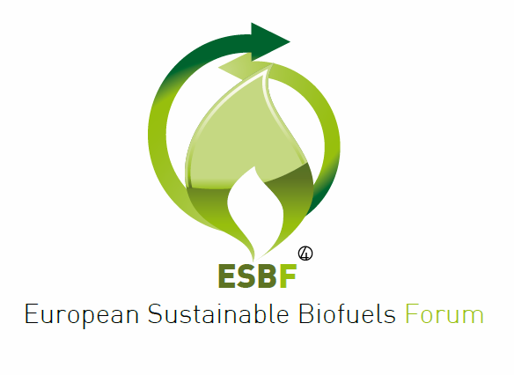

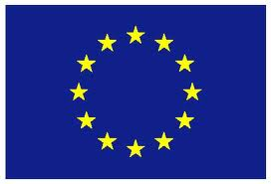

European Commission

Directorate General for Energy

**European Sustainable Biofuels Forum**

**Sustainable Biofuels Stakeholders Committee**

*Commission Directorate General for Energy*

*November 28th, 2012, 10h30 – 17h15 - Rue Demot, 24 – Brussels, room 3/58*

Registration Form

*(Please note that the information needed for the registration is quite comprehensive and includes*

*information on ID documents number so to allow entrance at EC Commission buildings)*

* **YES I wish to register** for the **European Sustainable Biofuels Forum Stakeholders Committee** which will be held next *November28th, 2012* at the above mentioned address and I hereby engage myself to transfer the registration fee of **42€** to the bank account mentioned below (covering lunch expenses)
* **NO I cannot register** for the **European Sustainable Biofuels Forum Stakeholders Committee** this time but please keep me informed about next meetings, activities and events

Title …........... Name: ……………………………..… Family Name……….………………………………………………………….

Nationality …………………………………………………………………………………………………………………………………………...

ID document kind (Passport / Nat. ID card)……………………………. ID document n. …………………………………..

Company/Legal entity: …………………………………….……………Position: …………………………………………………….…

Email: ………………………………………………………… Skype ID …….…………………………………………………………….…

Telephone: ………………………………………………… Fax: …………………………………………………………………………...

Address:…………..…………………………………………………………………………………………………………………………………..

Signtaure: …………………………………………..

Signature: ……………………………………………..

I

In order to complete your registration, please transfer at your earliest convenience and by the deadlines below the amount of ***42 Euros*** (lunch expenses) with a bank transfer free of charge to the following bank account:

**Account n. 743-0109872-82**

**IBAN account: BE25 7430 1098 7282**

**(*European Biodiesel Board, Boulevard St. Michel 34, 1040 Bruxelles)***

**Bank KBC, Auderghem Centre, Swift Code (BIC): KREDBEBB**

**Chaussée de Wavre 1662 – 1160 – Brussels (Belgium)**

Please send the filled form to[**info@sustainablebiofuelsforum.eu**](mailto:info@sustainablebiofuelsforum.eu)

or by fax to the number: +32 (0)2 763 04 57 (for questions please contact us on ESBF phone number +32 (0)2 761 95 00)

preferably **by November 18th, 2012** and in any case no later than November 24th, 2012



28/ADM/12

***European Sustainable Biofuels Forum***